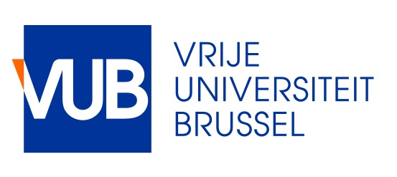
Master Mind Scholarships VUB
Application form Academic year 2017-2018
This word version application is only for applying for a Master Mind scholarship and does not replace the online VUB application. Students wishing to apply for the scholarship should apply first to take up a Master degree programme at the VUB
( http://www.vub.ac.be/en/studying-at-the-vub/how-to-enroll )

In the framework of the Master Mind Scholarships Fellowships for Excellent Students, the Government of Flanders will award a few scholarships to outstanding Master students from all countries. Students need to have graduated with the equivalent of magna cum laude, first class honours, Grade A.

Applicant

last name
first name(s)
date of birth (dd/mm/yy)
gender | male female
civil status | single married
nationality
e-mail address
personal email address
international passport number*
international passport
date of issue (dd/mm/yy)
international passport
place of issue
international passport
expiry date (dd/mm/yy)
current student status | bachelor master Other (please specify)
current/latest study field
current/latest study programme
study start date (dd/mm/yy)
expected graduation date (dd/mm/yy)
number of ECTS already awarded
grade point average
academic awards (if applicable)
previous scholarships
publications

Master Programme

name of Flemish host institution | Vrije Universiteit Brussel
department
official name of the master programme you want to follow
number of credits of the master programme you want to follow
VUB student number

Language scores

type of language test taken
date test taken (dd/mm/yy)
writing
reading
listening
speaking

Permanent address details
street
country
post code
city
mobile phone number

Living and studying in Brussels is expensive, this scholarship will not cover all costs. More information about how much money you need can be found on http://www.vub.ac.be/en/studying-at-the-vub/expenses. Please note that the Vrije Universiteit Brussel will decline any claim for financial support in any form.

Certification of authenticity

The undersigned states on his / her honor that the information provided in this application is correct and complete.

date of submission
signature of applicant

The application needs to be submitted by 13 April 2017 by sending it to Hilde.De.Haseleer@vub.be.

Documents to submit with the application:
- Copy of admission letter issued by the Student Administration Center at the Vrije Universiteit Brussel
- Copy of acquired degree(s) and Transcript(s) of records. If written in another language than Dutch, French or English, enclose a certified translation
- Copy of official language test results
- Letter of motivation (maximum 2 A4 pages)
- Letter of recommendation from 2 professors of your Home university

Please note that only complete applications will be taken into account.

